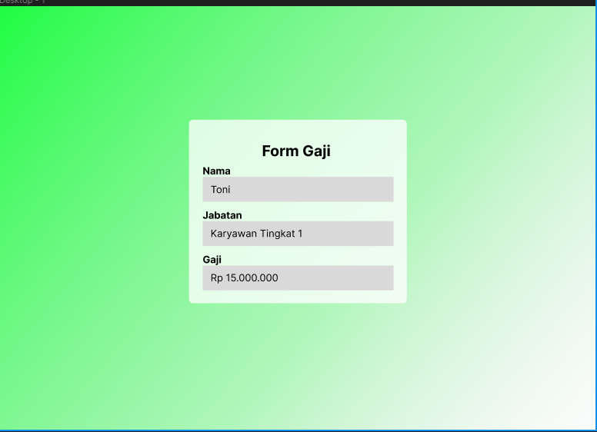

<https://www.figma.com/file/E8jCbr9RCDLvVeCWkbYE5g/Untitled?node-id=0%3A1&t=bL6Hbj1iOZoiN7YW-1>